DevOps CIA-2 Report:
Name: Aarav Suriyanarayanan
ID: 23011102004

Task 1 (commit messages are distributed across all tasks):

Initial Repo setup:

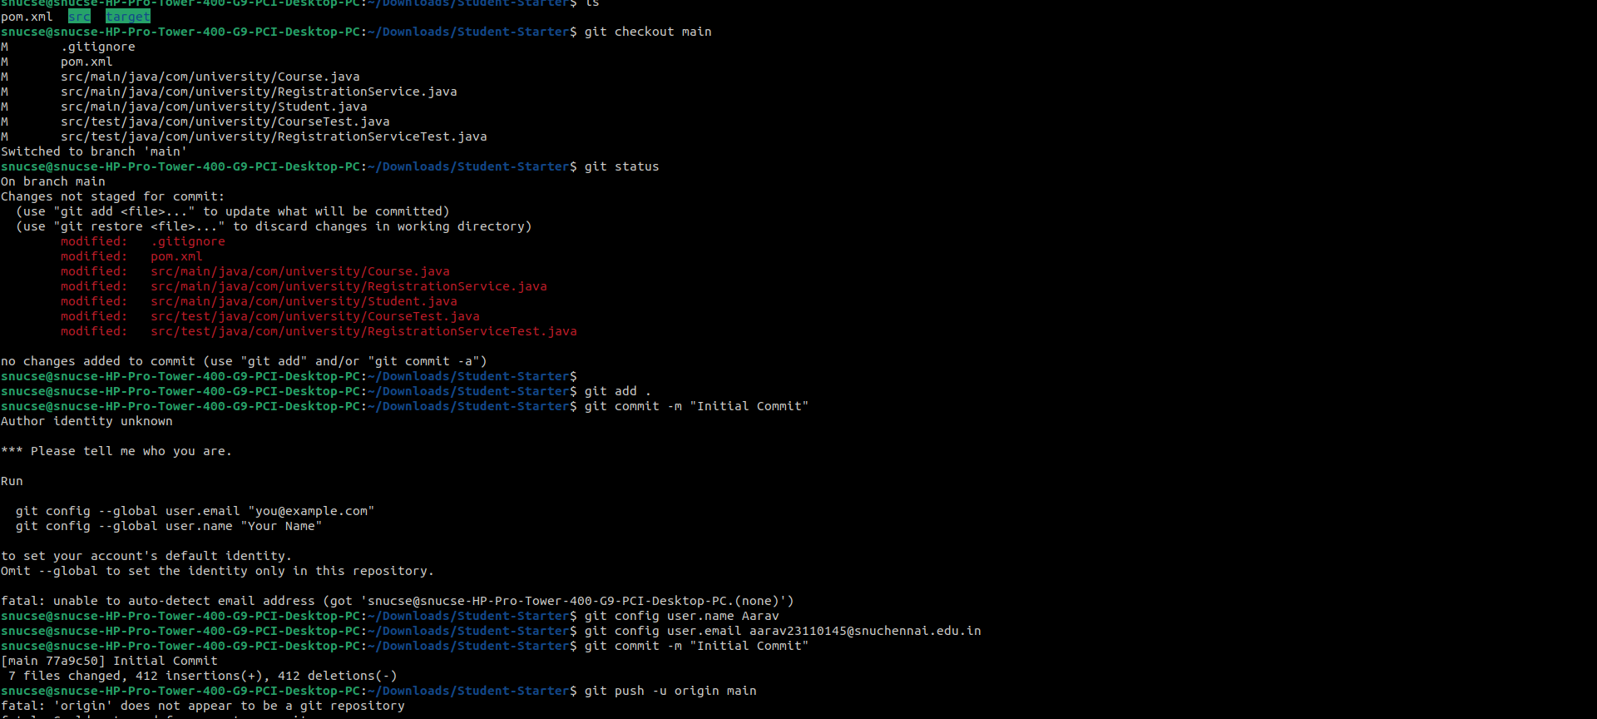

Task 2:

File Setup and Writing POM Files:
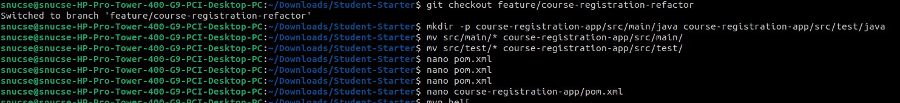

Maven Clean Test:
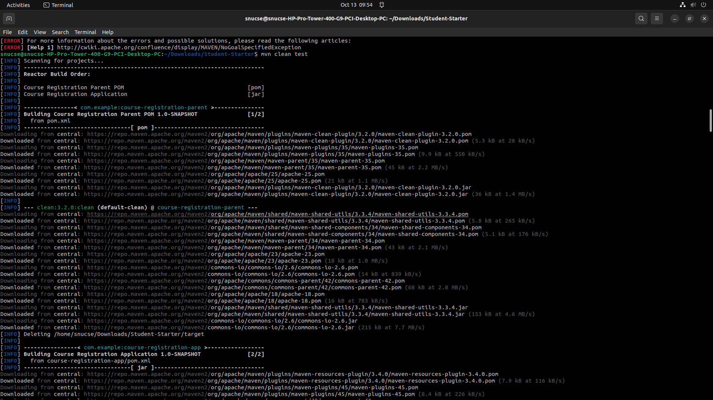

Clean Test Success and Maven Package:
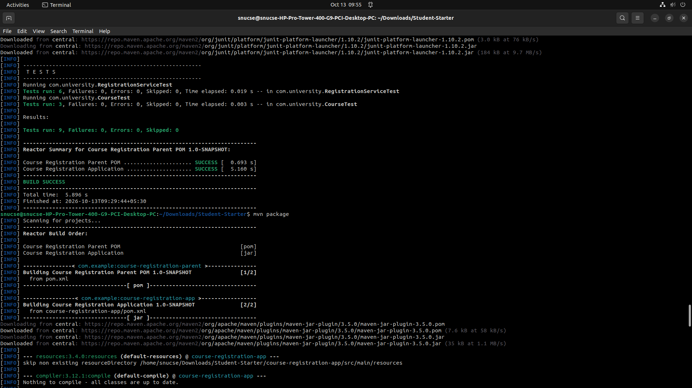

Maven Package success and Task-2 Commit:
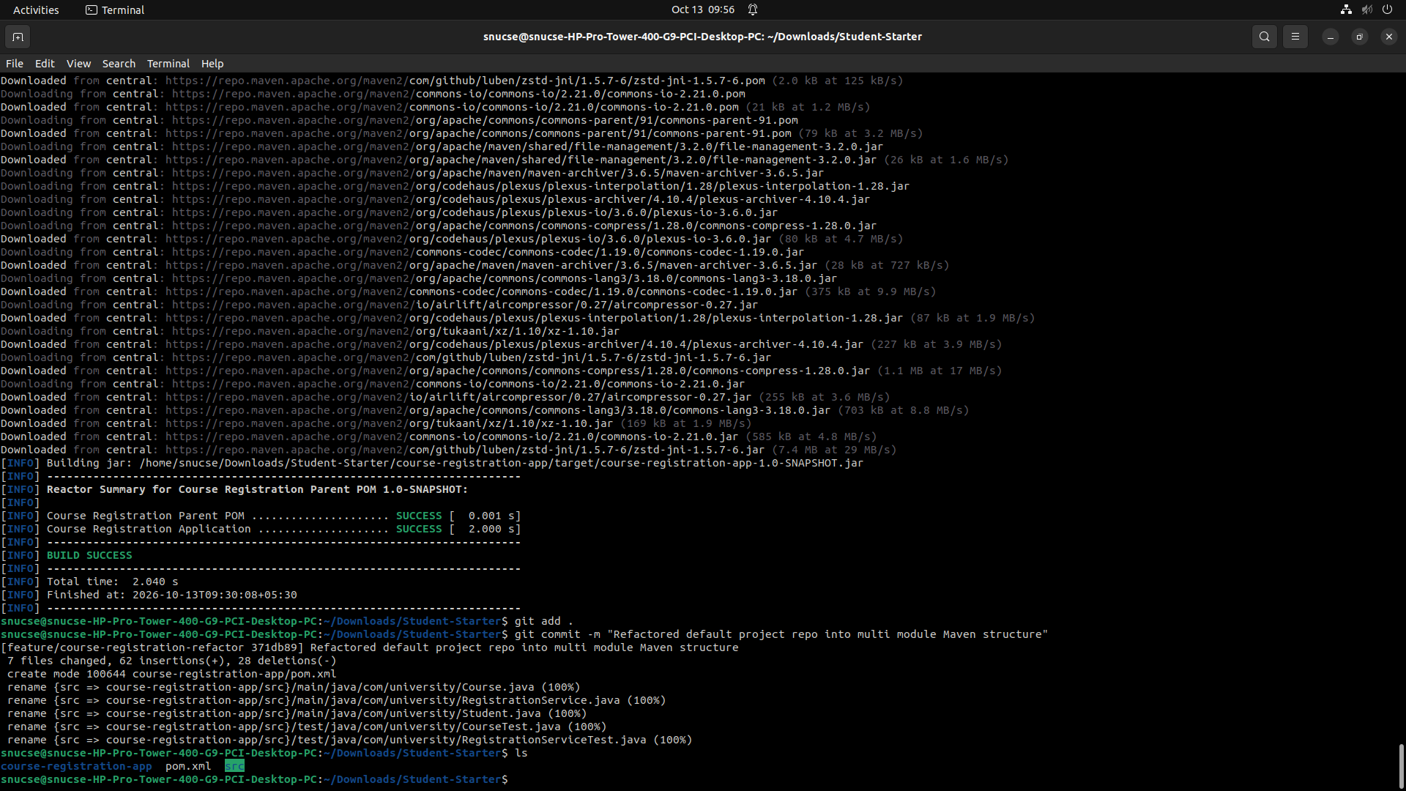

Task-3:

RegistrationService.java Fix:
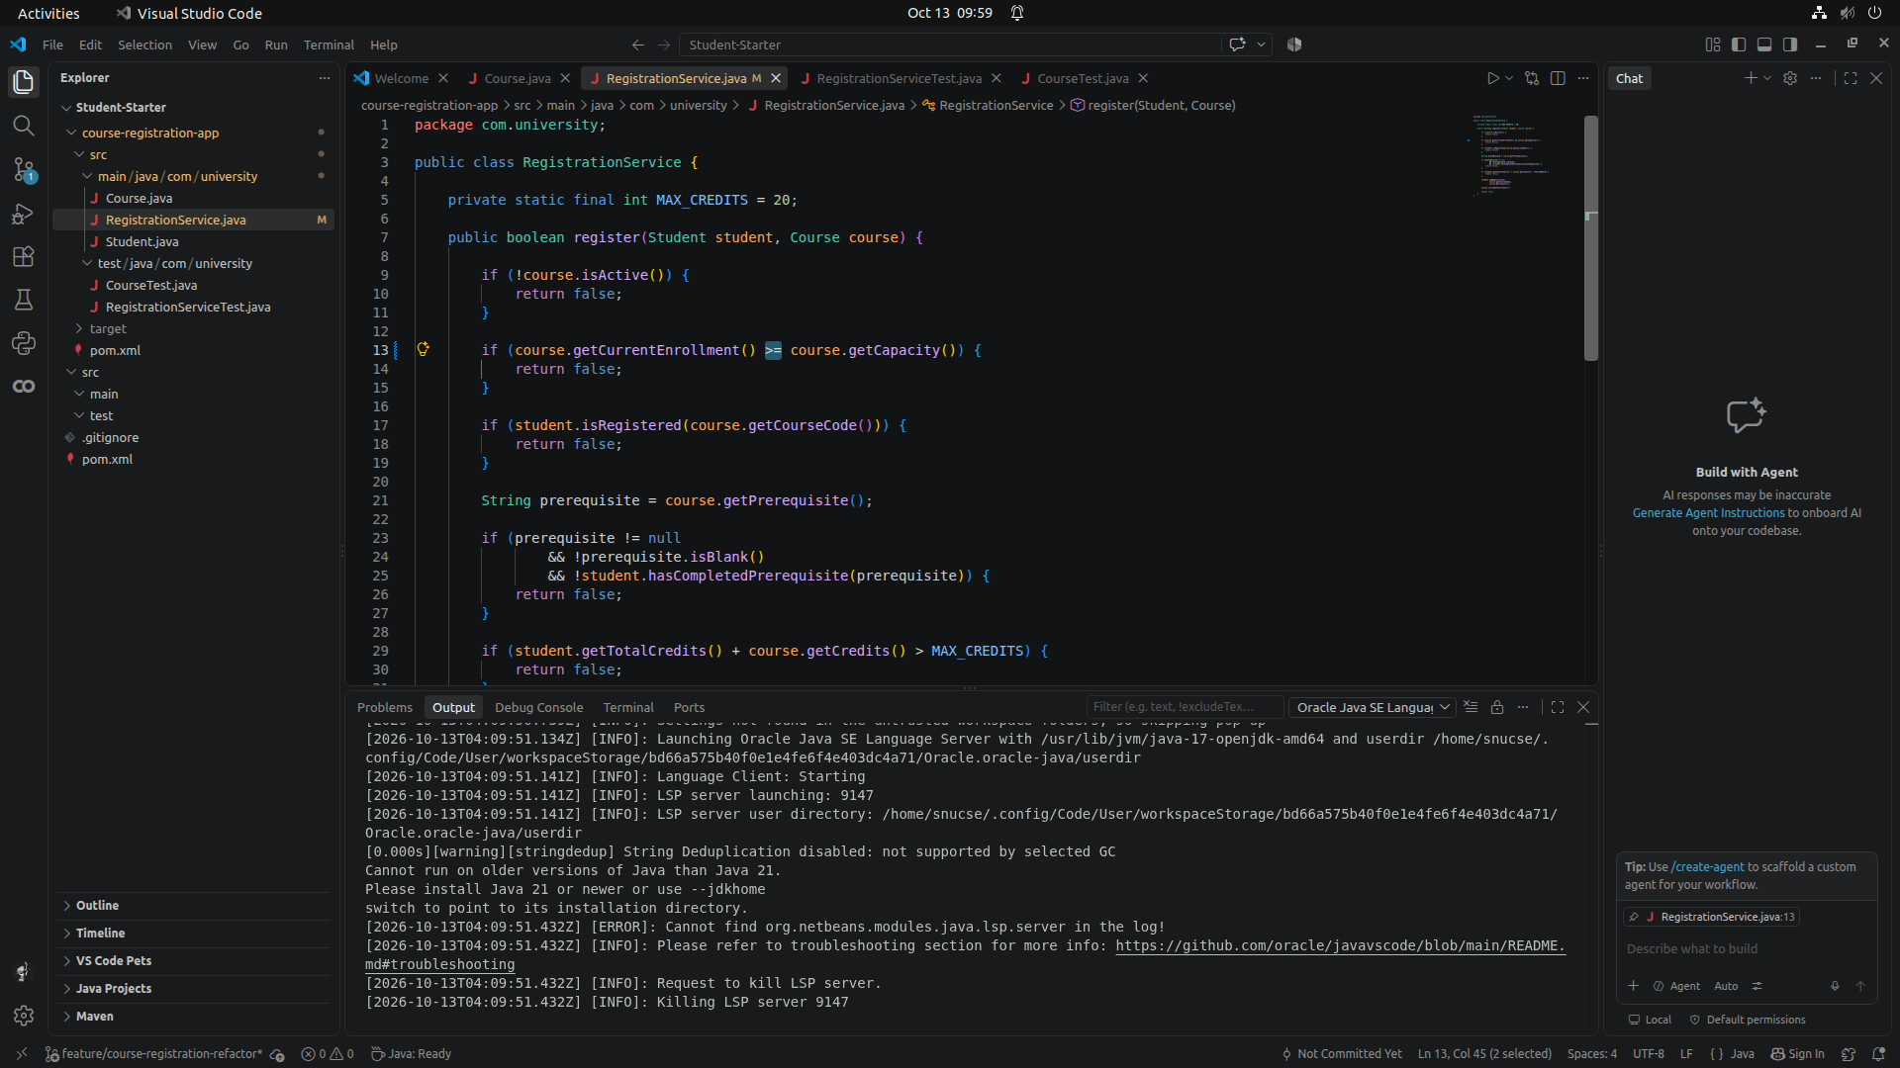

Added Required Unit Tests:
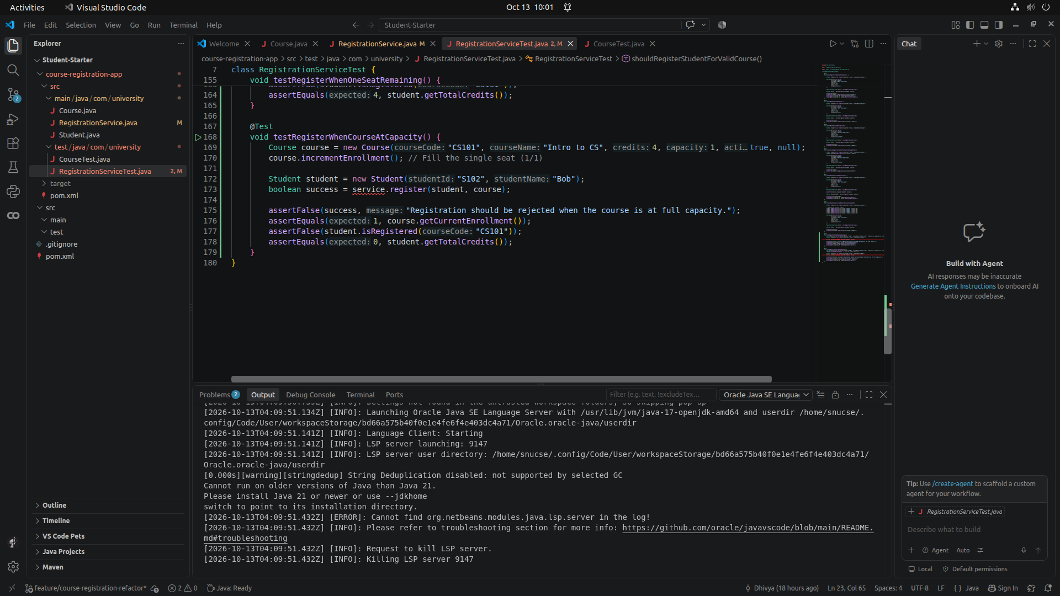

Maven Clean Test:
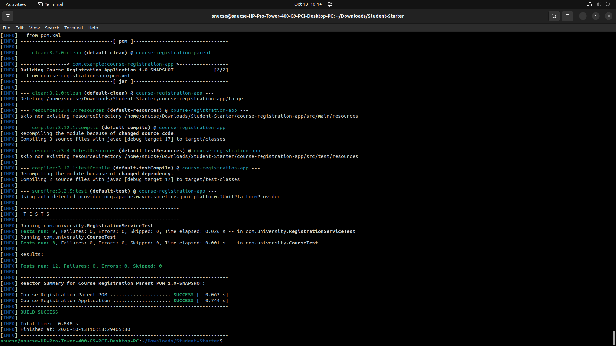

Task 4:

Credit Limit Change (Question Set A):
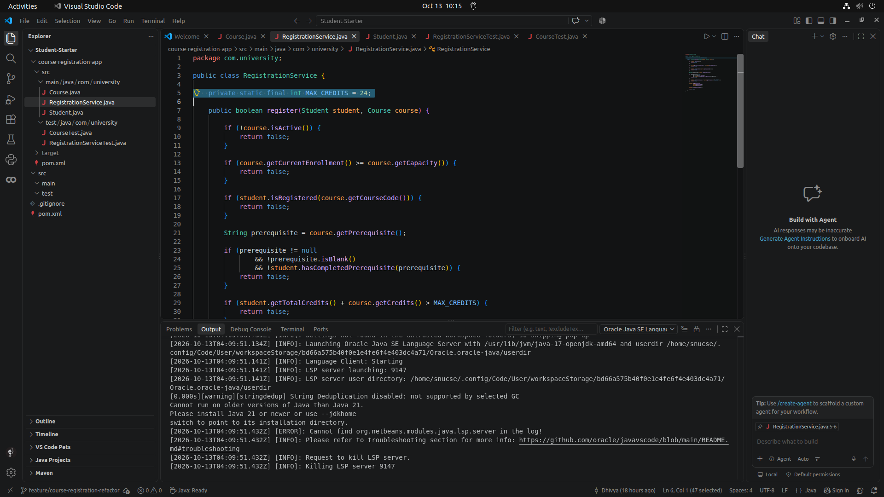

Rerunning Unit Tests:
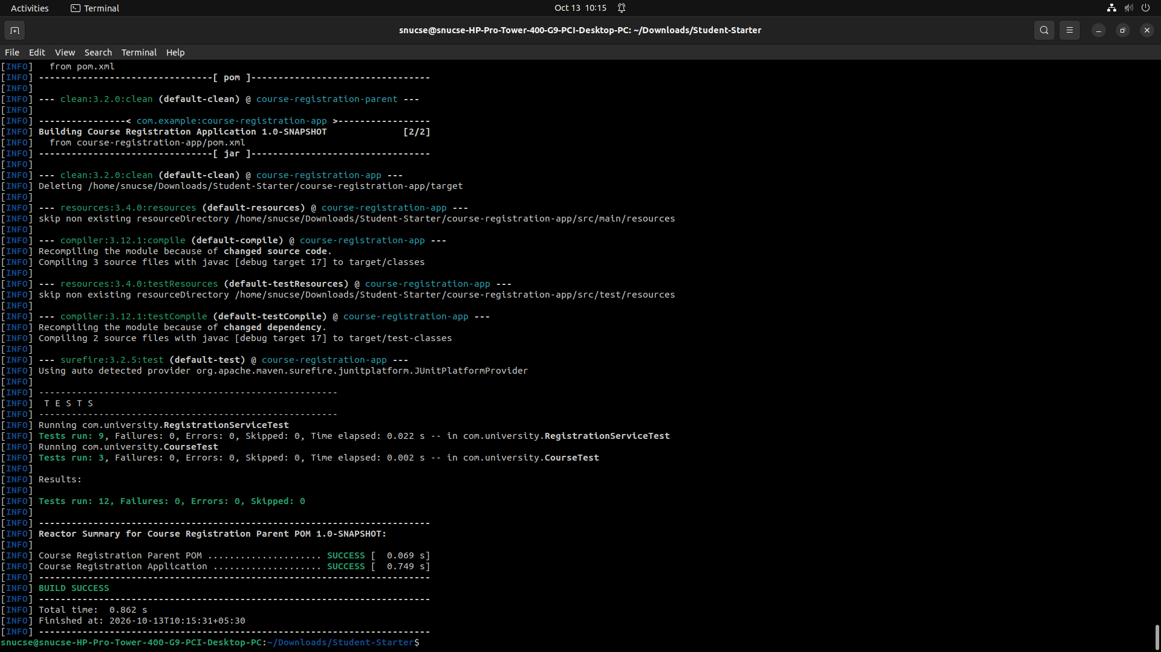

Case-Insensitive Duplicate Regisration (Question Set D):
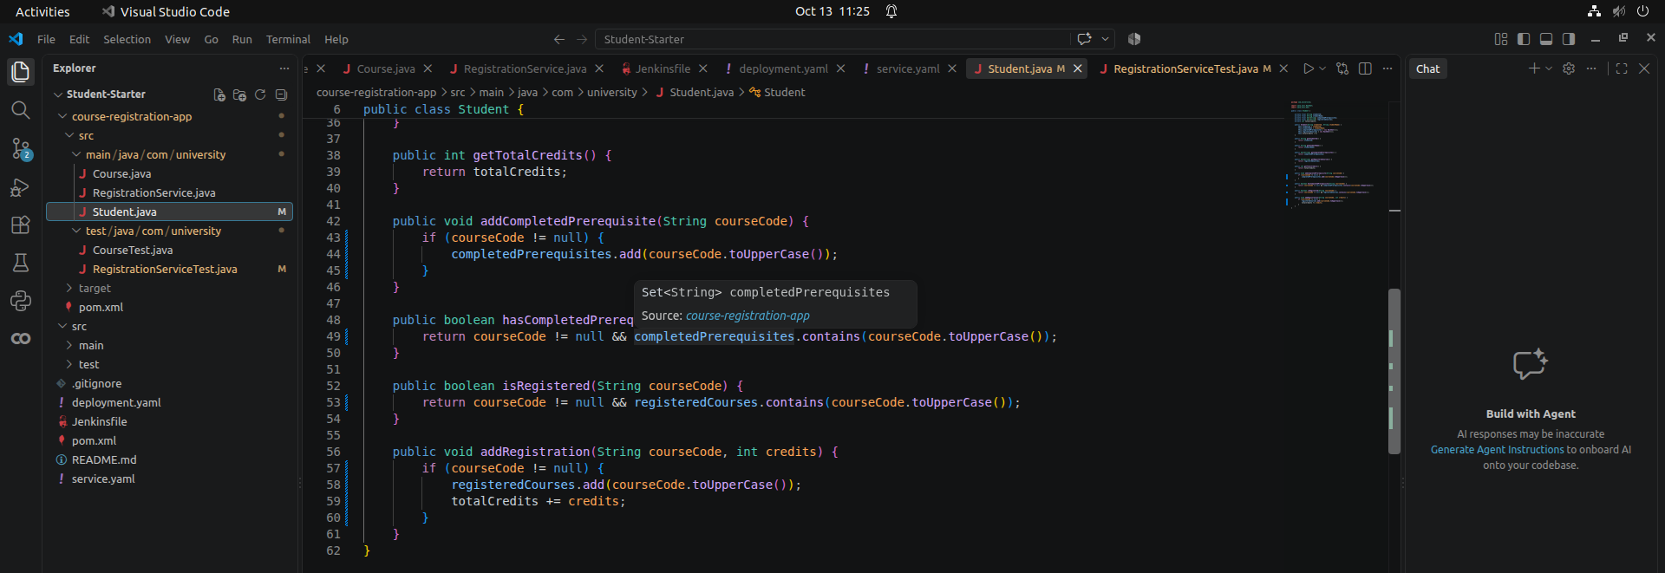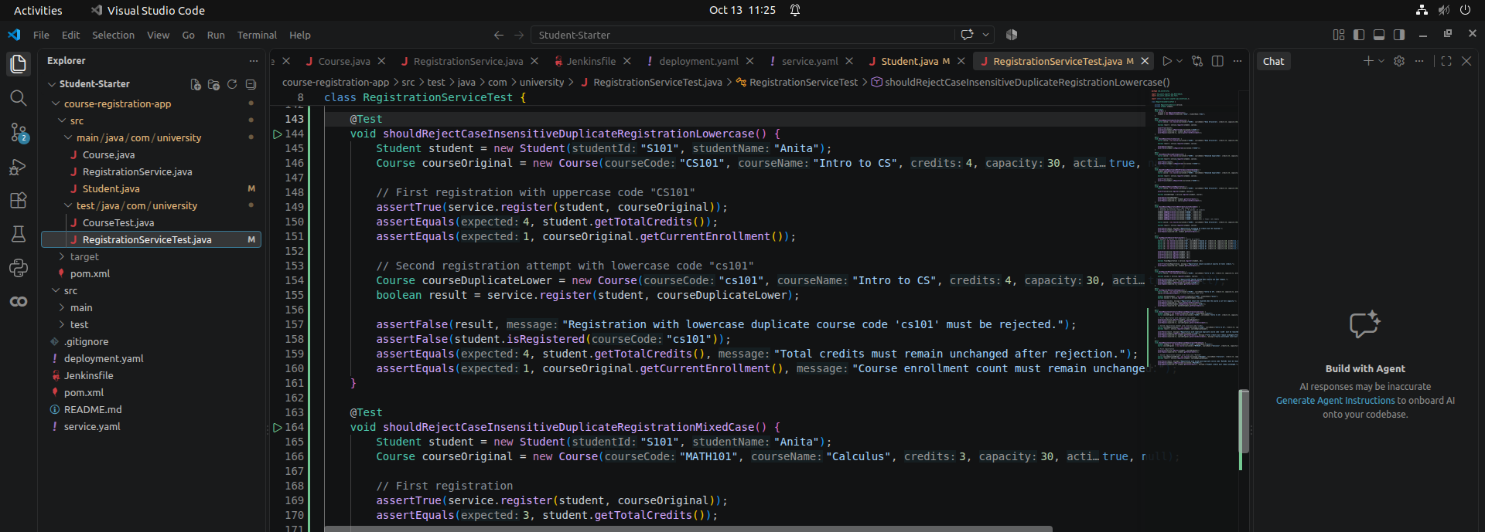

Rerun Clean Test: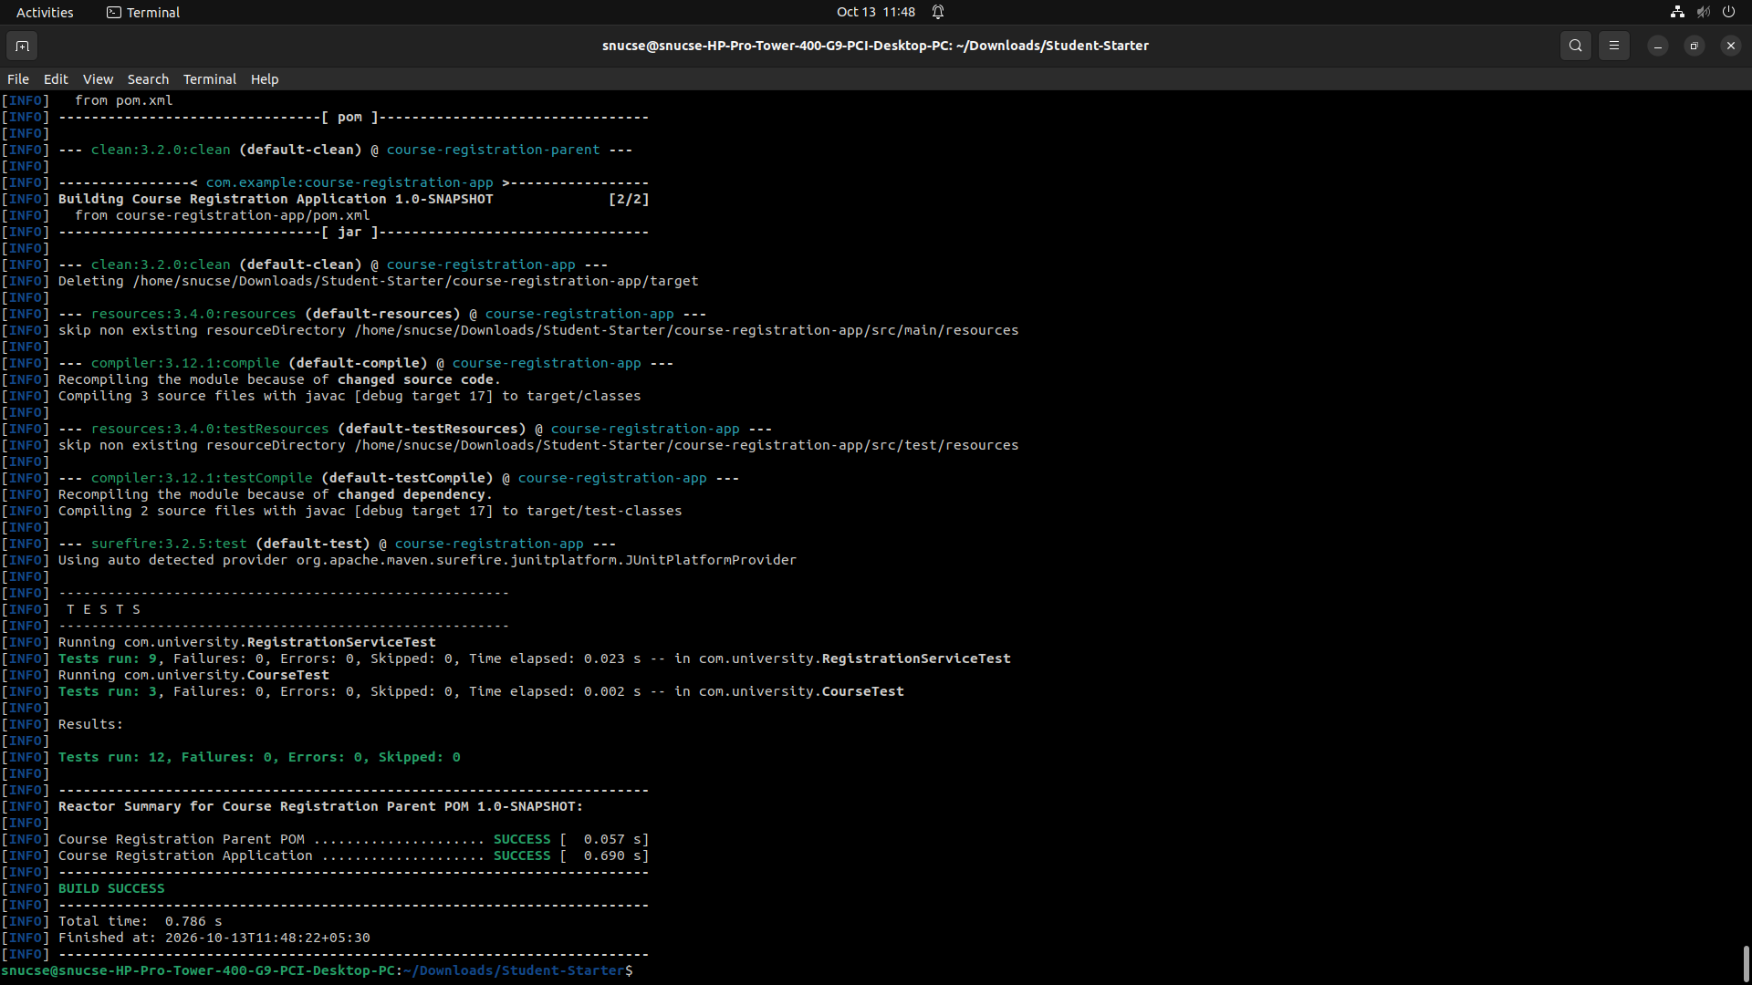

Task 5:

Creating JenkinsFile: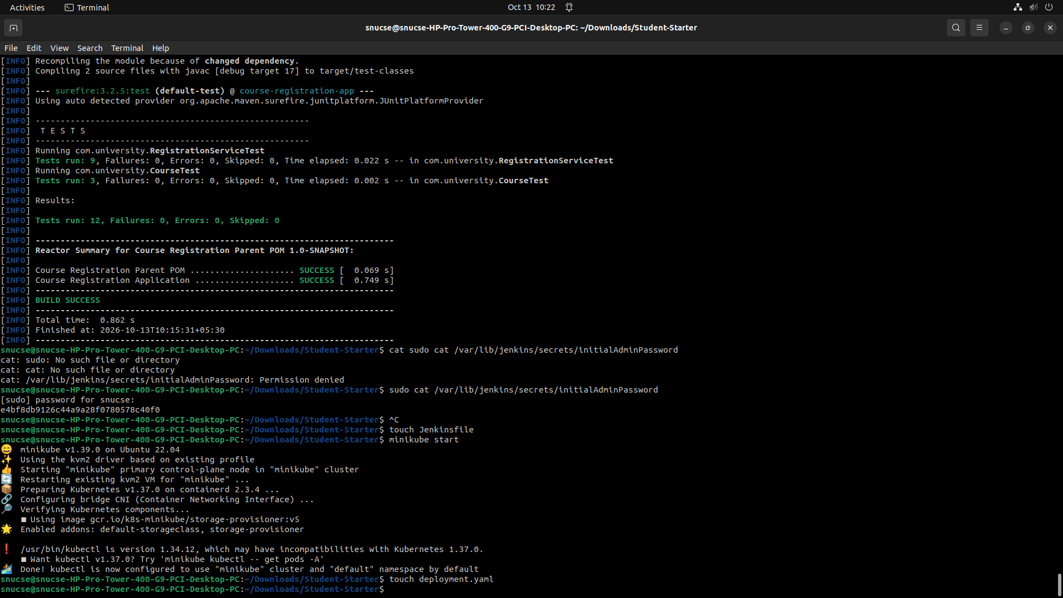
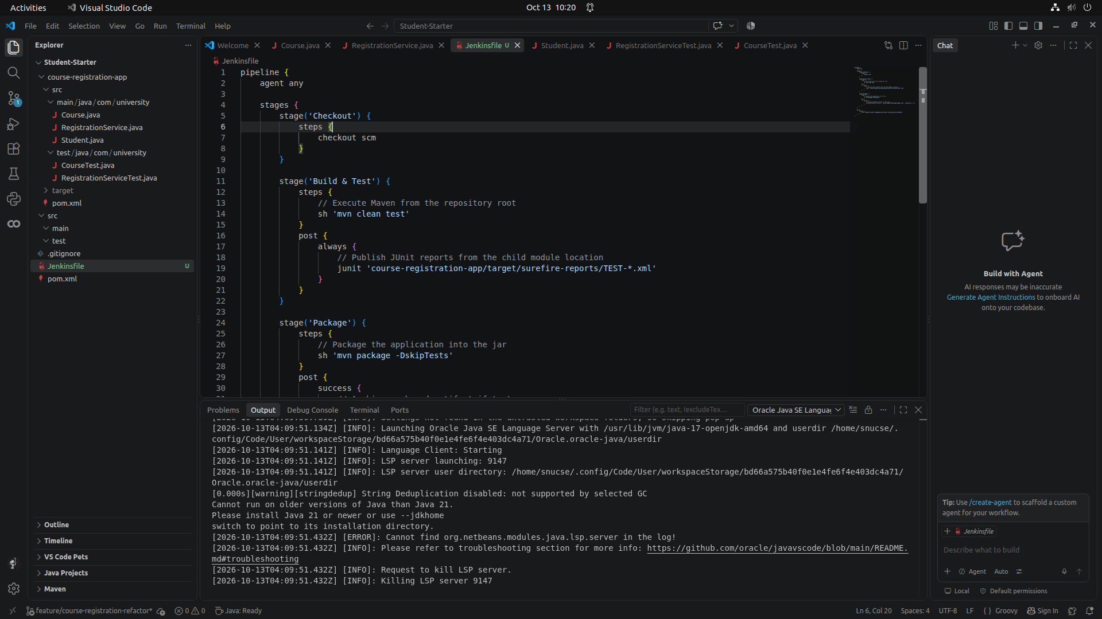

Commit Jenkinsfile: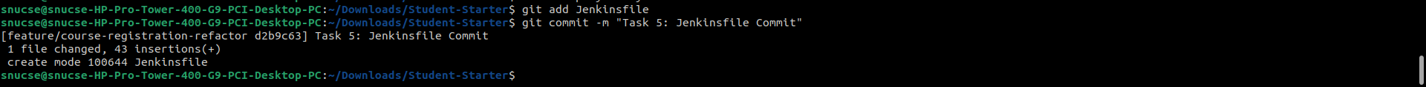

Task 6:

Starting Minikube and Created YAML file:

Deployment.yaml: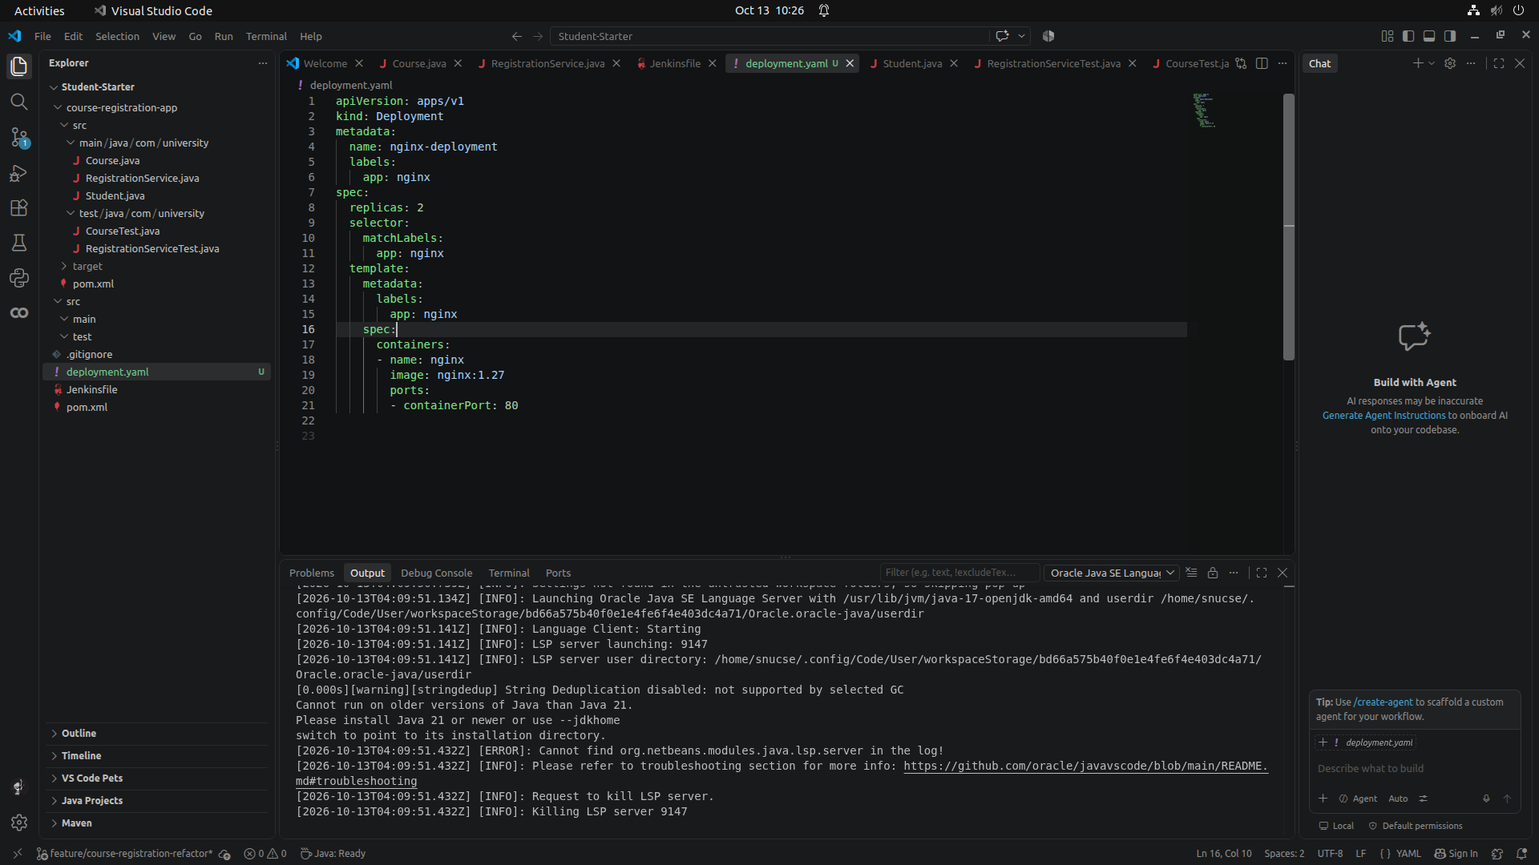

Service.yaml creation AND Task 6 Commit of YAML files: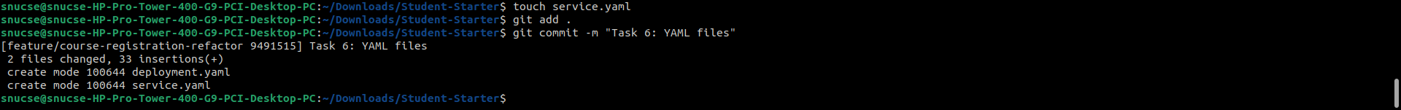

service.yaml: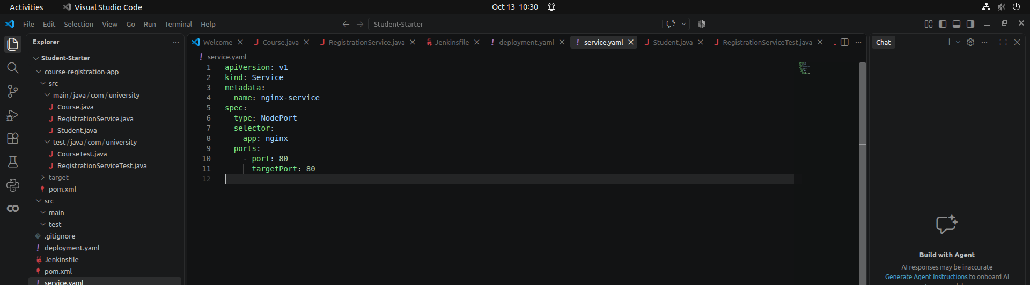

Apply Configs and Verify Deployment:
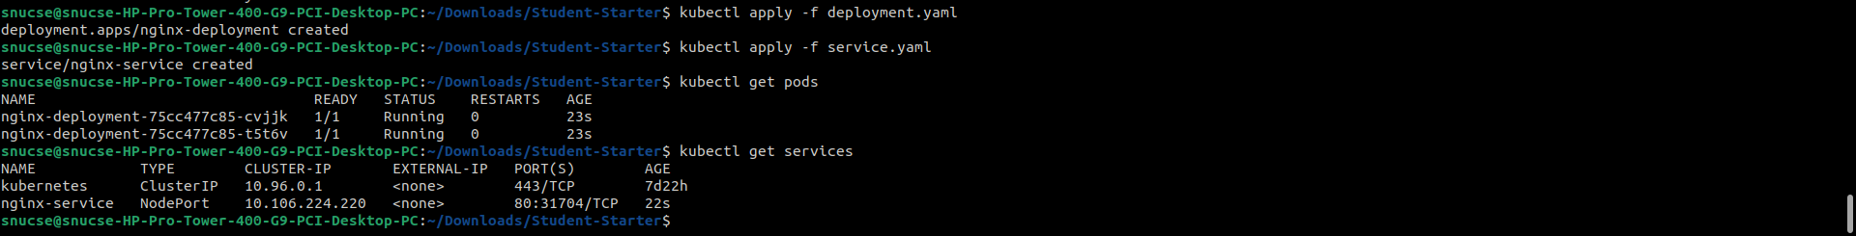

Scaling and Self Healing: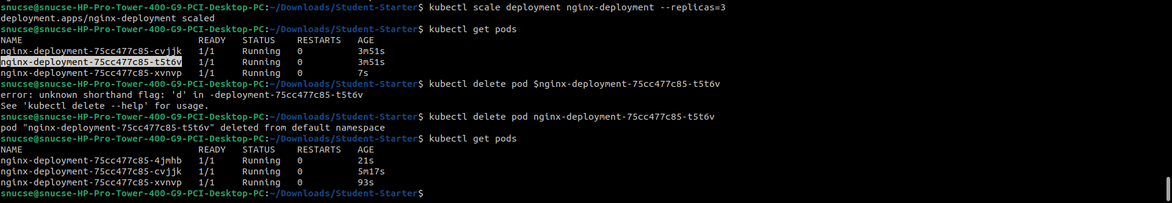

Task 7:

Setup And Execution Instructions:

Build and Test: mvn clean test
Package: mvn package
Kubernetes Deployment:
kubectl apply -f deployment.yaml
kubectl apply -f service.yaml

Git Evidence:

Feature Branch Name: feature/course-registration-refactor
Commit History:

076720b (HEAD -> feature/course-registration-refactor) Updated Readme with actual Question set qs implemented
e70d701 Question Set D- Bug Fix
8b9e344 Question Set D
629c609 Final commit
b1856e4 Added Final README
9491515 Task 6: YAML files
d2b9c63 Task 5: Jenkinsfile Commit
6929bc6 Task 3: Indentation Mistake
5300b37 Task 3: Fixed Mistake in new unit tests
74fbd4c Task 3: Resolved Error and added Unit Tests
371db89 Refactored default project repo into multi module Maven structure
cef2bff Initial student assessment starter

Maven Evidence:

Parent-Child POM Structure:
Parent POM manages shared compiler settings and JUnit 5 dependency versions. Child module `course-registration-app` inherits configuration. Reactor successfully builds both modules.

Build Results: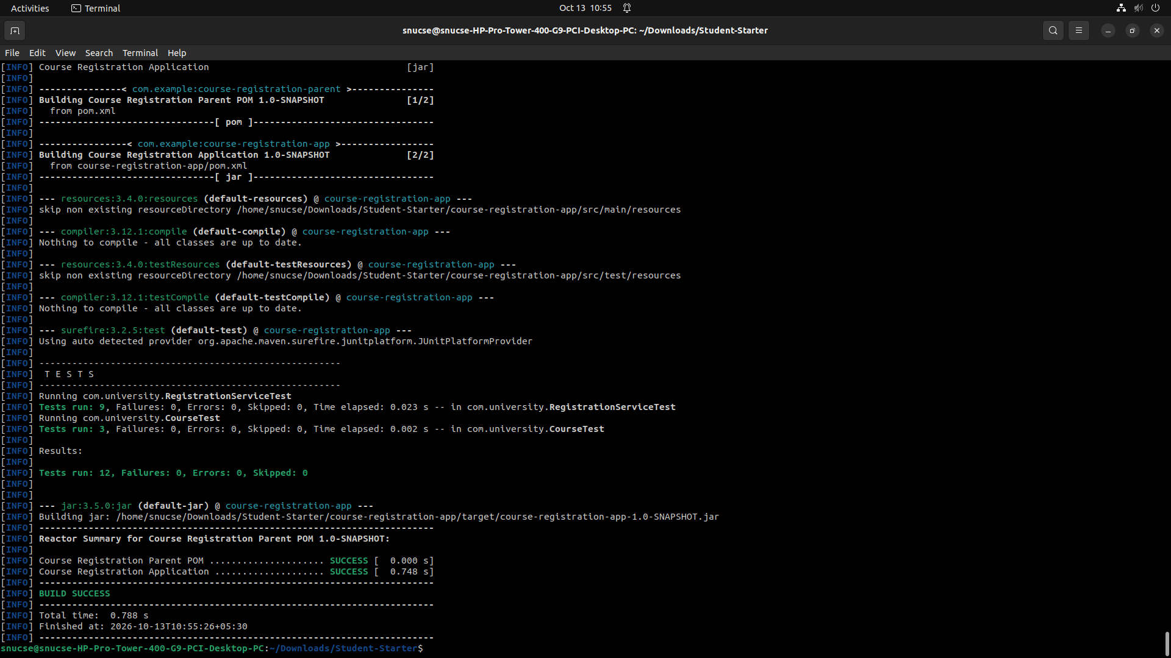

Jenkins Pipeline Explaination:

Jenkinsfile:
pipeline {
agent any

stages {
stage('Checkout') {
steps {
checkout scm
}
}

stage('Build & Test') {
steps {
// Execute Maven from the repository root
sh 'mvn clean test'
}
post {
always {
// Publish JUnit reports from the child module location
junit 'course-registration-app/target/surefire-reports/TEST-*.xml'
}
}
}

stage('Package') {
steps {
// Package the application into the jar
sh 'mvn package -DskipTests'
}
post {
success {
// Archive packaged artifact if tests pass
archiveArtifacts artifacts: 'course-registration-app/target/*.jar', fingerprint: true
}
}
}
}

post {
failure {
echo 'Pipeline failed. Packaging and artifact archiving were prevented.'
}
}
}

Jenkins uses Linux ‘sh’ steps to execute stages. It publishes the test reports via junit.
Sample command: junit 'course-registration-app/target/surefire-reports/TEST-*.xml
It archives artefacts only on successful pipeline build.

Kubernetes deployment evidence:

deployment.yaml:
apiVersion: apps/v1
kind: Deployment
metadata:
name: nginx-deployment
labels:
app: nginx
spec:
replicas: 2
selector:
matchLabels:
app: nginx
template:
metadata:
labels:
app: nginx
spec:
containers:
- name: nginx
image: nginx:1.27
ports:
- containerPort: 80

service.yaml:
apiVersion: v1
kind: Service
metadata:
name: nginx-service
spec:
type: NodePort
selector:
app: nginx
ports:
- port: 80
targetPort: 80

Change Summary and Limitations:

Bug Resolved: Capacity check error fixed
Change Request Completed:
Capacity increased from 20 to 24.
Case-insensitive duplicate registration guards implemented.
Full Pipeline set up: Maven, Jenkins and Kubernetes fully set up for the project

Limitations:

Done only on a local minikube environment.
Docker not used at all for the project.

Final Jenkins Pipeline run: 